# Identity Translation POC for Dover Corporation

## Goal:

Demonstrate an Identity Transition module for Azure IoT Edge to work with a Brownfield (non IoT) device.

## Code Overview:

Line 71 establishes the TWIN callback, which is how the leaf devices are shared with the module

Line 74 establishes a method handler, so we can initiate C2D methods

Lines 76 – 81 establish a timer that manages all leaf device.

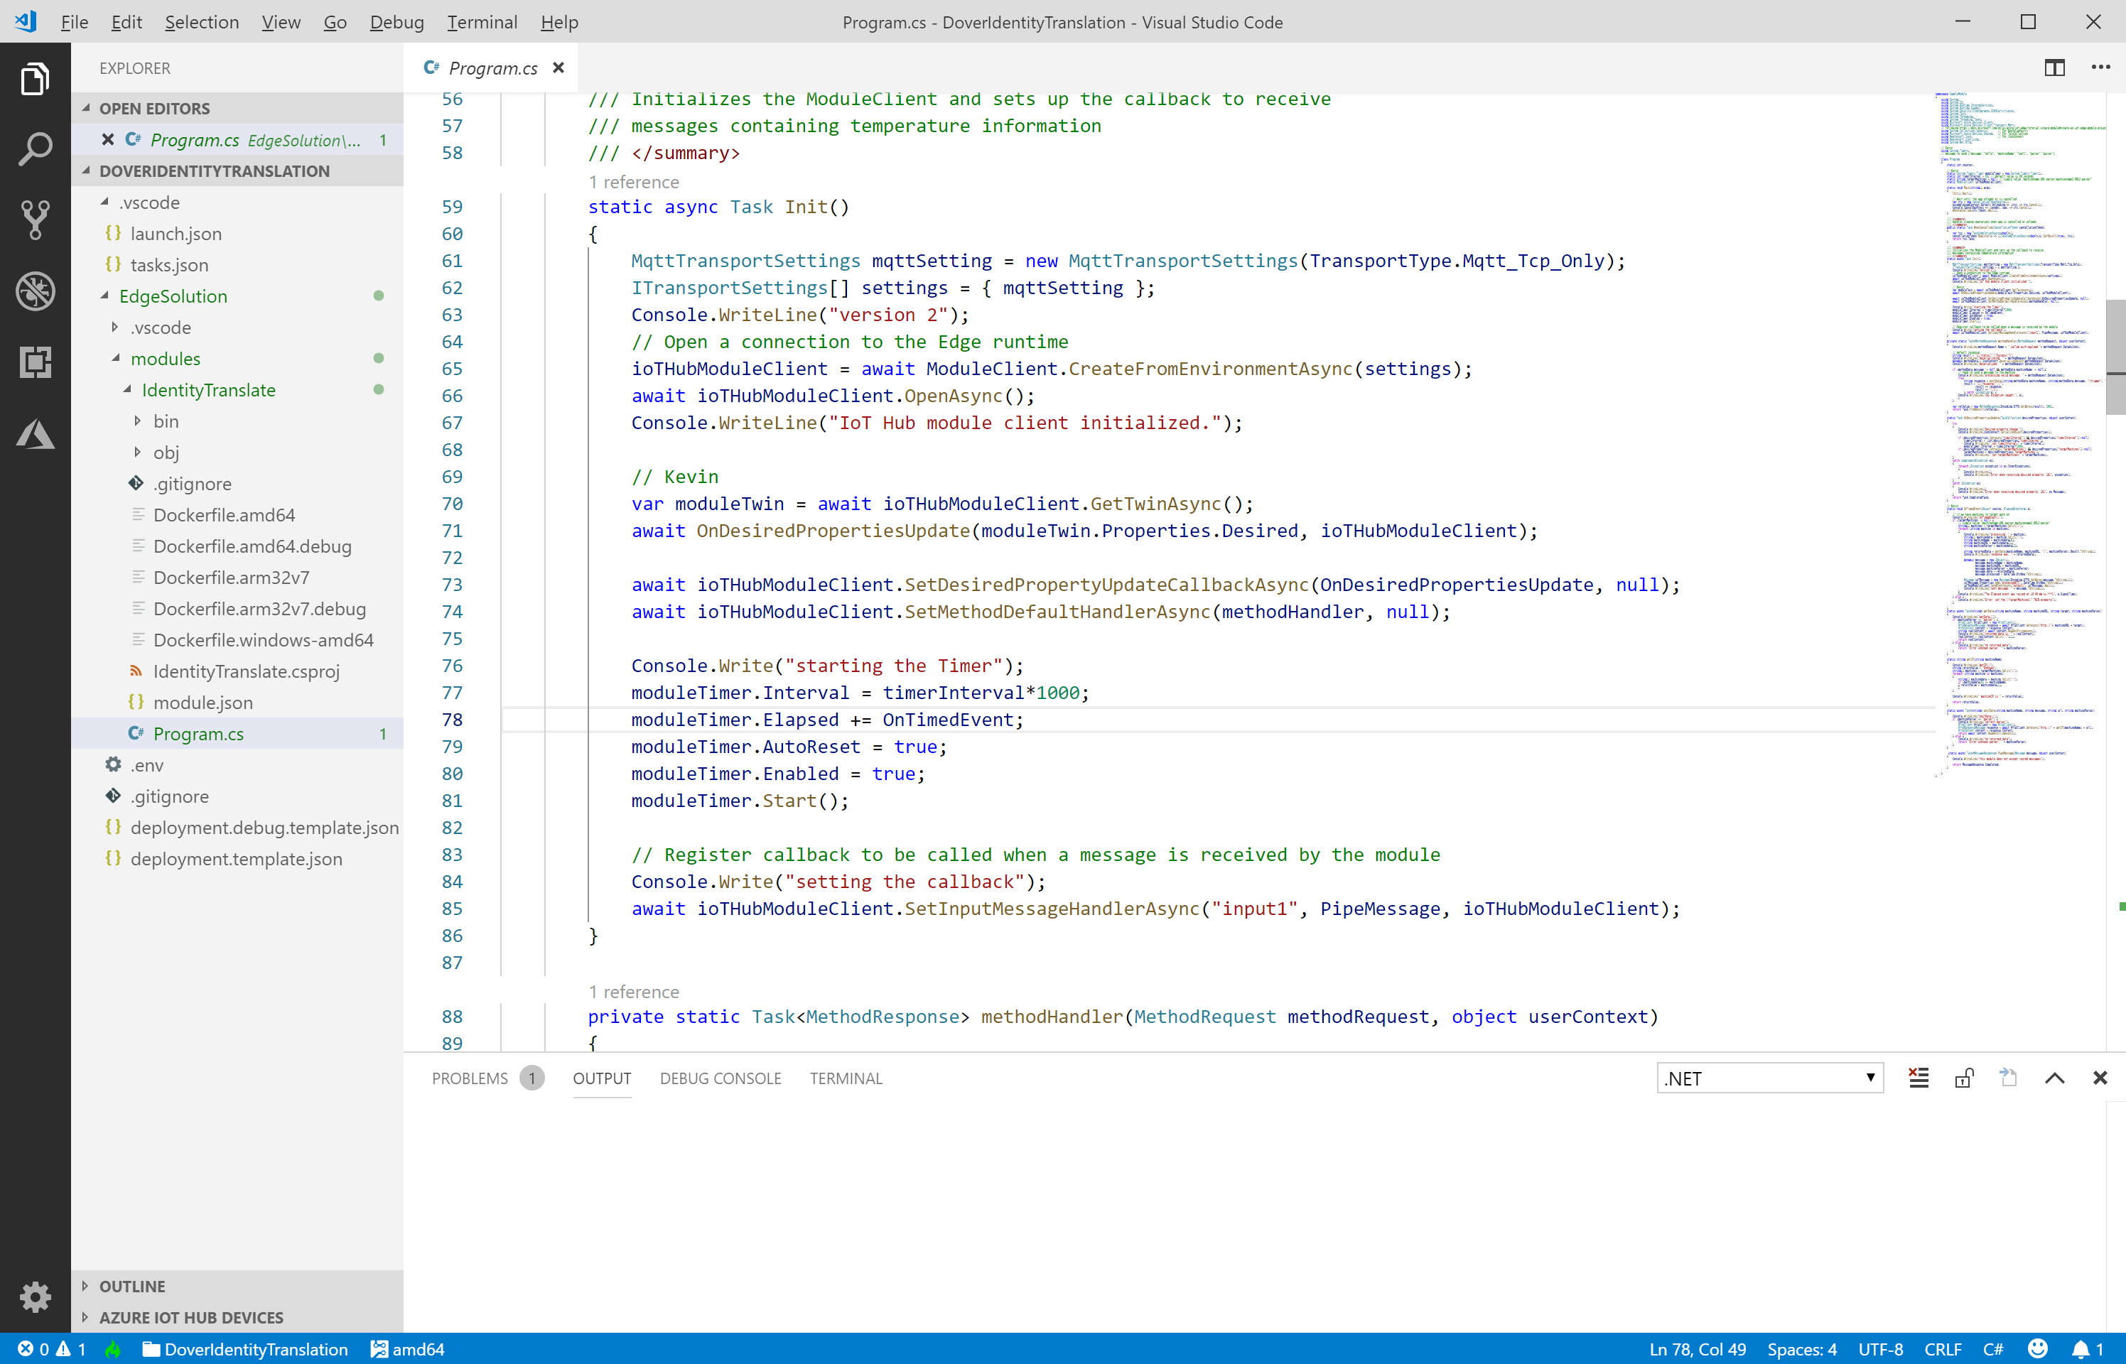

Lines 88 – 113 establish the method handler when a C2D method on the module is called. Note line 102 post data to brownfield device, in this case using the /trigger URI.

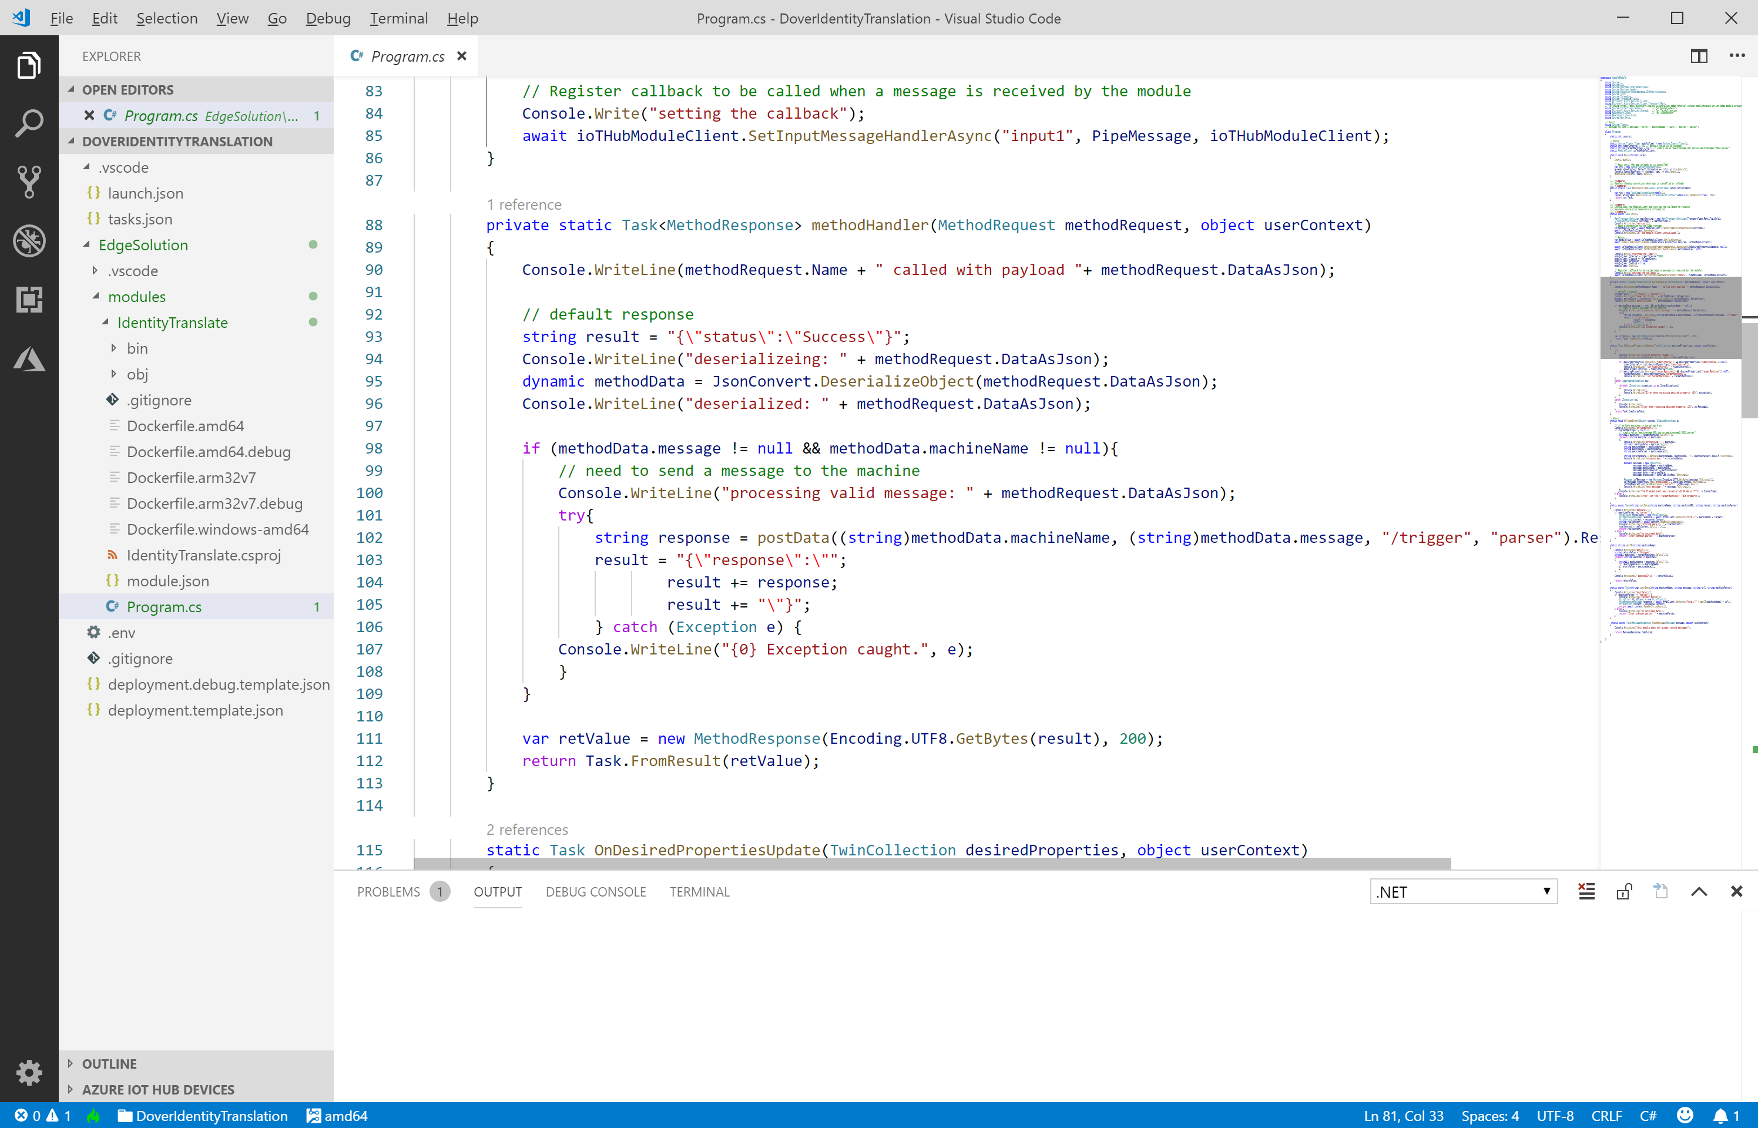

Lines 183 – 198 show the process of getting data, using an HttpClient.

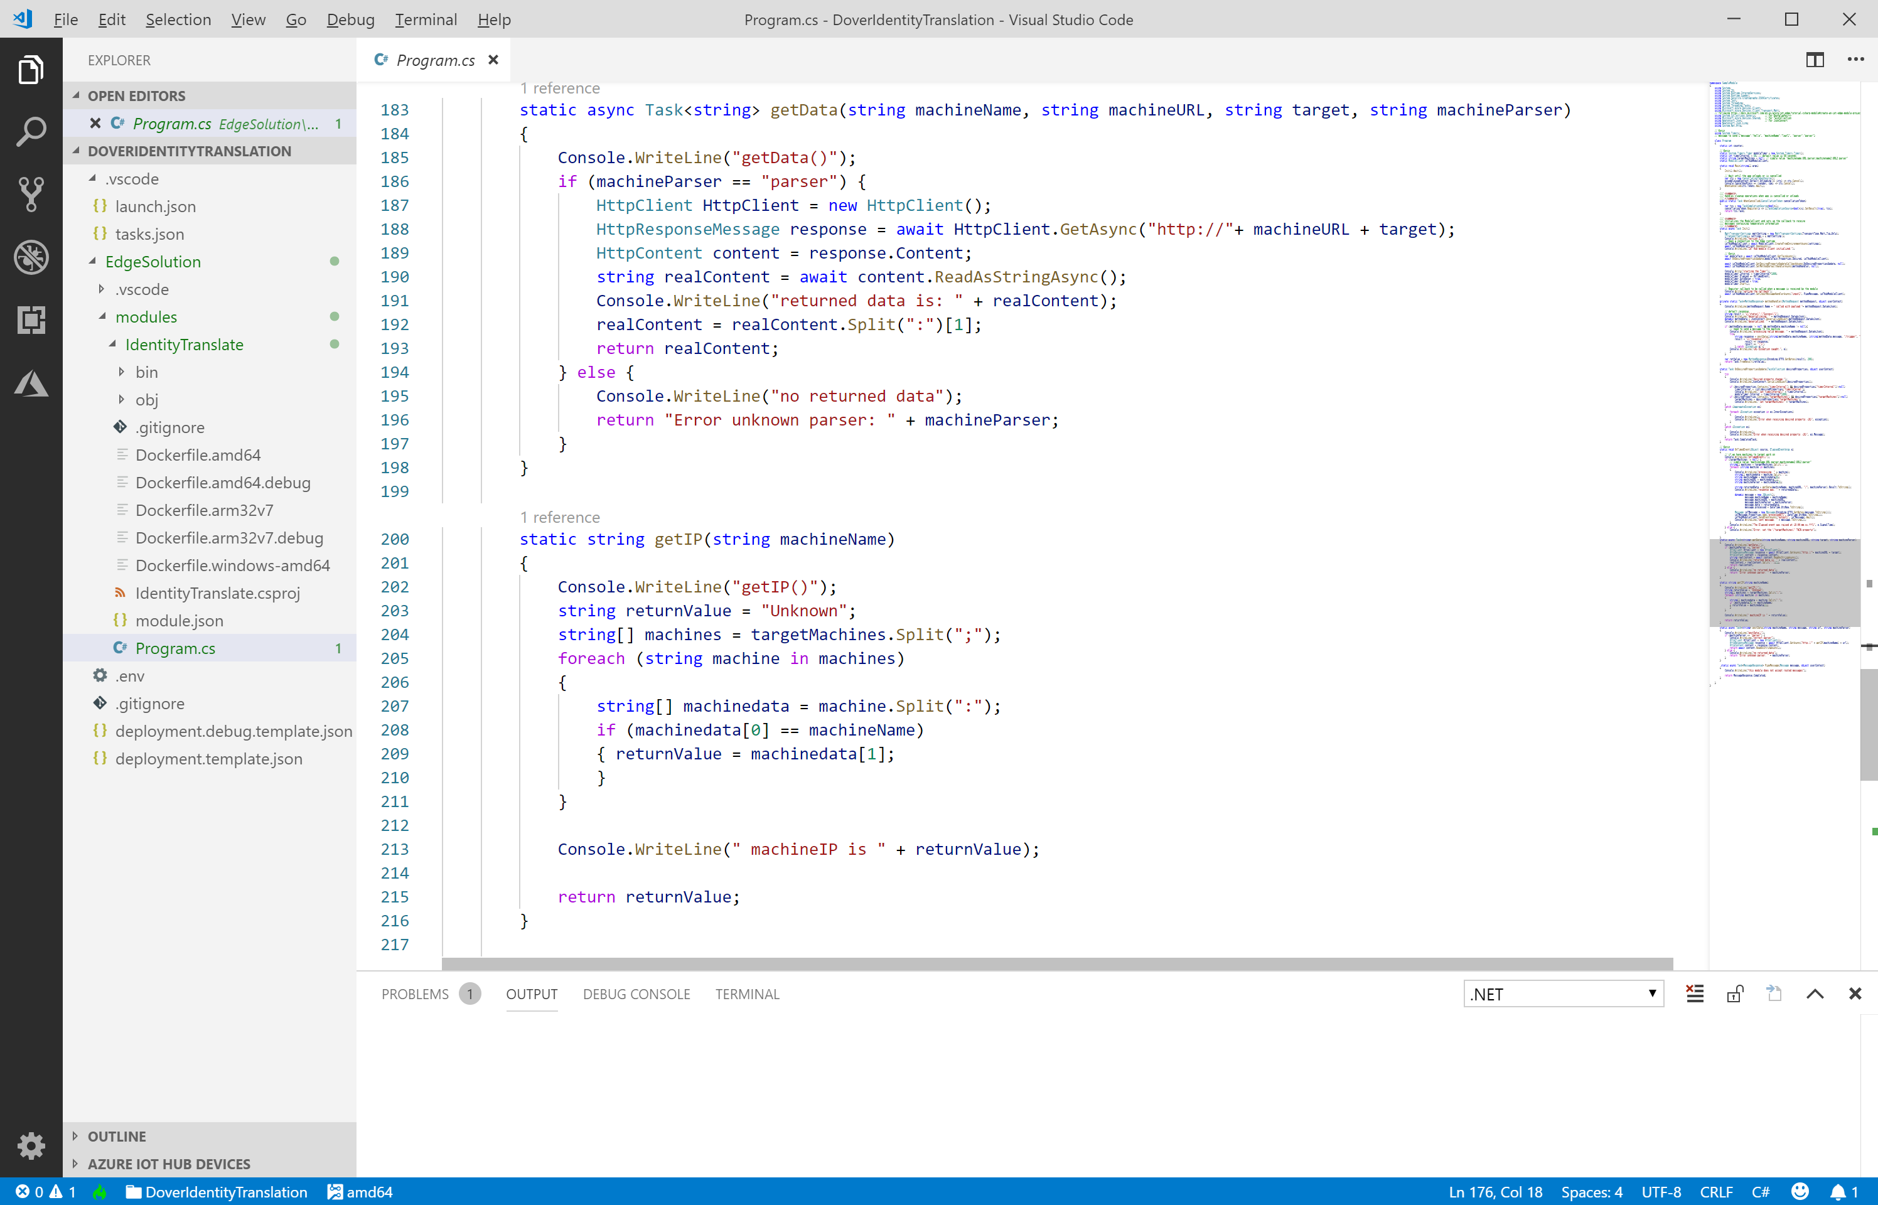

Lines 147 – 182 establish the timer, which, per line 162 gets data from the device and lines 165 – 174 sends a message to IoT Hub.

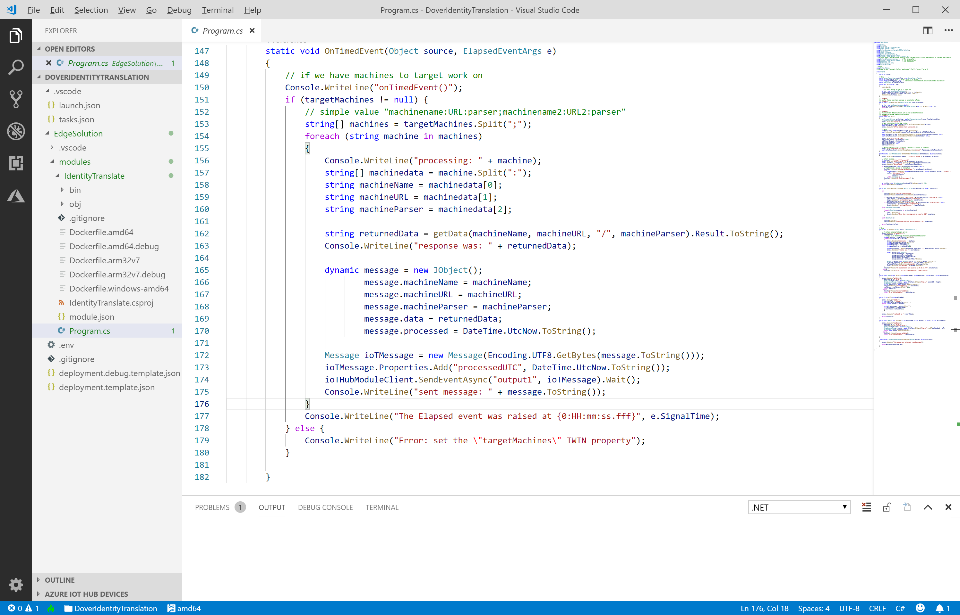

Lines 200 – 216 show the process of getting the connection settings for a named device, when called by a C2D method.



For this simple demonstration, we just used a TWIN property to instruct the Module what devices and how often to connect.

